**Description and purpose of the Application**

The app being developed is a personal assistant management application which is designed with the aim of simplifying mobile device usage as it will automate various tasks that are necessary daily. In the application users will be able to:

- display all missed calls

- dialing numbers to make calls

- send short messages services

- send emails

- search the web

- play music as either mp3 or mp4 files

**Class diagram models**

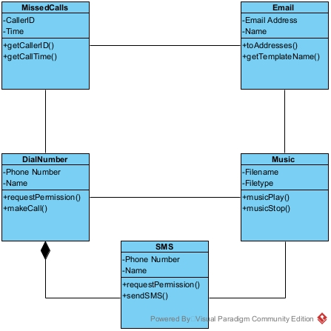

**Method and Class explanation**

MissedCalls: The class which contains the methods necessary when displaying missed calls which include the “getCallerID()” method which is used to retrieve the number from the missed call to be displayed

DialNumber: The class which contains the methods needed to make a phone call including the “requestPermission()” method which is used to request permission from the system in order to dial a number

Email: The class which contains the methods necessary to send an email which include the “toAddresses()” method which is used to configure the addresses to which the different emails are sent

Music: The class which contains the methods needed to play music including the “musicStop()” method which is used to start playing a selected music file

SMS: the class which contains the methods needed to send various sms’ to various recipients including the “sendSMS()” method which sends a specified message to someone given their phone number and or name